# External Interface Requirements

# User Interfaces

Map View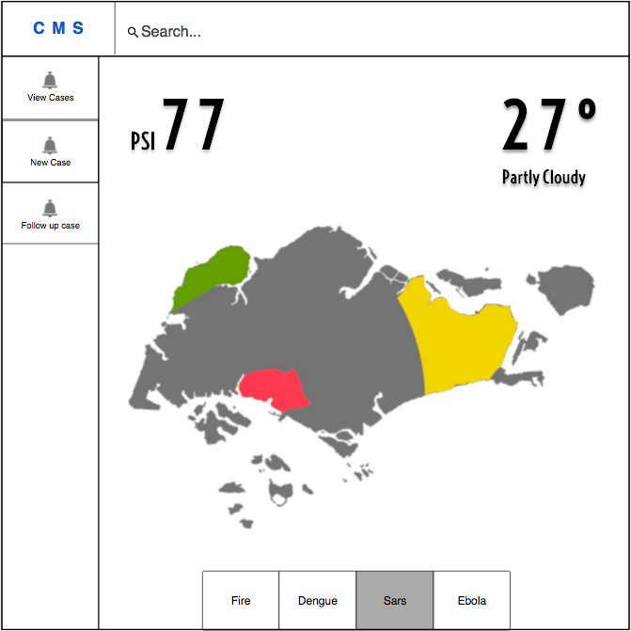

# Map view - Crisis Overview

# 

### Incident List

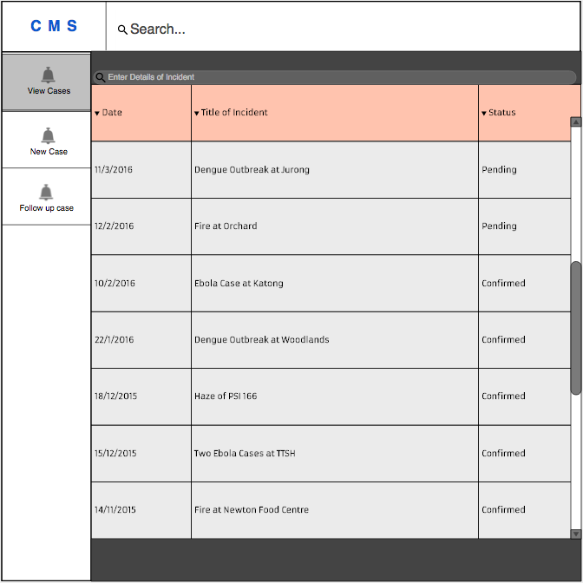

### Incident List - Sort by column

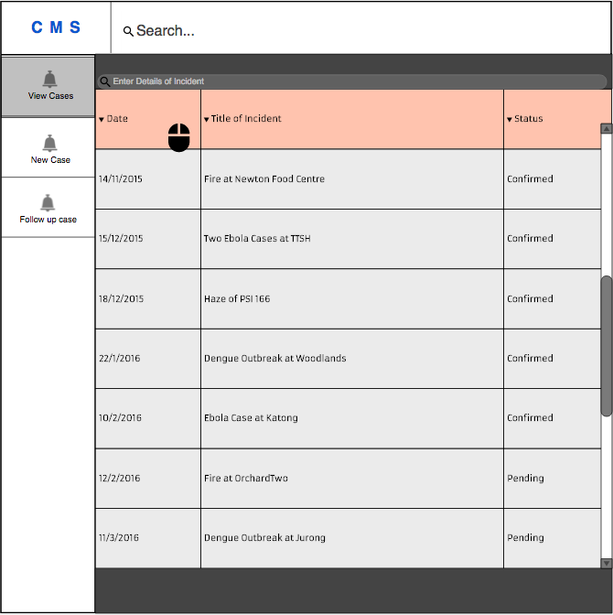

### Incident List - Sort by column

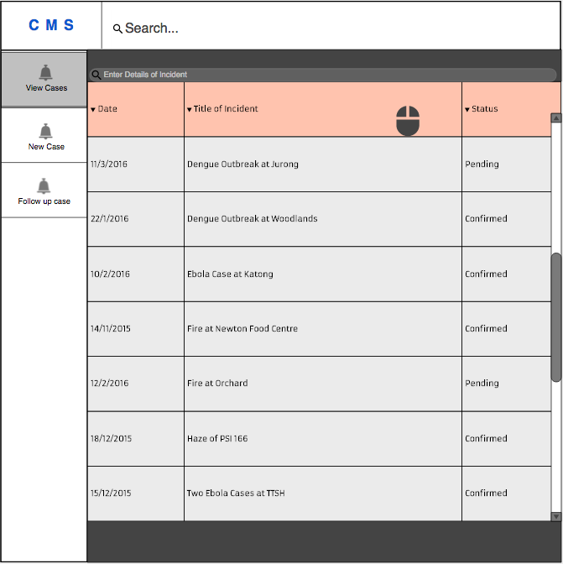

### Incident Status Update

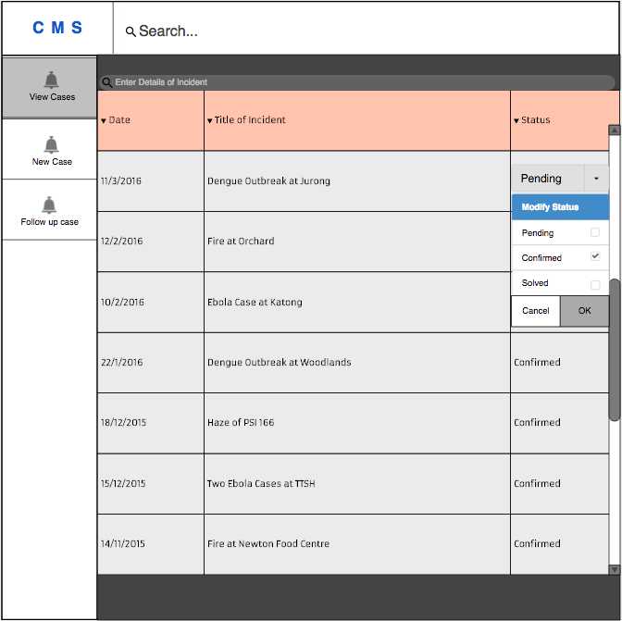

### Incident Submission Form

### Request Form

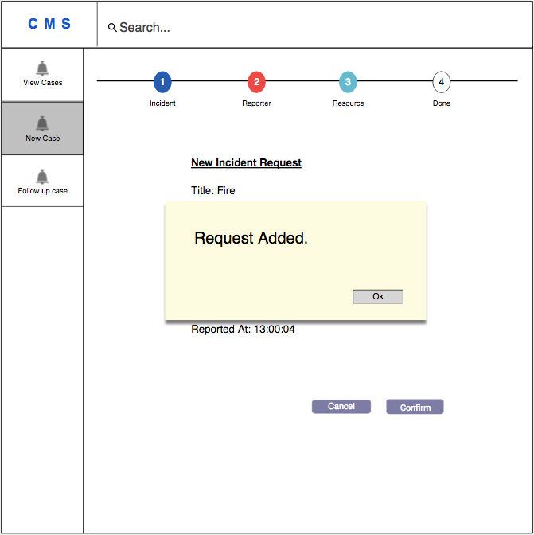

### Incident Summary

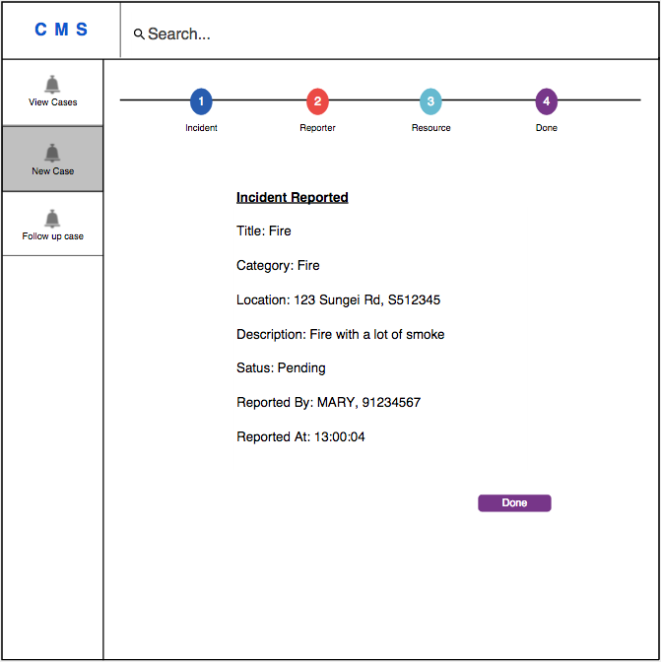

## Hardware Interfaces

The Hardware Interfaces of the system are handled by the Ubuntu with Apache 2. No hardware dependent code will be written.

## Software Interfaces

* **Operating System**
  + The software is being designed to run on most of the operating systems namely Ubuntu, CentOS and Windows Server.
* **Web Server**
  + The software is being designed to run on Apache version 2.4.18.
  + The software is being designed to run with PHP module version 5.5.
* **Database**
  + The software will access the MySQL database for the following features.
    - Manage incidents
    - Generating status report
    - Making request to resources
    - Sending useful information periodically
* **Libraries**
  + The software will be created using the Slim framework version 3 for routing and middleware control.
  + The software will be created using the Propel Framework version 2.0 for Object-oriented realization.
  + The software will be created using the jQuery Framework version 2.2.1 for web client animation.
  + The software will be created using the Google Map Javascript API for map rendering and geocoding services.
  + The software will be created using the AngularJS framework for 2-way data binding.
* **Page Layout Tools**
  + The software will be created using the Twig Framework version 1.24.0 for template rendering.

## Communication Interfaces

· **Web Interface**

o The application will be accessed over the Internet. All features will accessible through the web site.

· **Request SMS**

o Call operators, Agency Staff and Key Decision Makers can send request to other government agencies for help and assistance. Within the SMS, the incident’s location and description will be included.